Data Operations - Merging / Joining

Definition
# Source: AI Source: Provided by: [Data Path: Persons Table -> ID Column: 1, Name_En Column: Motasem Essam] -> From: [Chatgpt (GPT‑5 Mini)] on [12/10/2025]
Merging or Joining is a data operation used to combine two or more datasets based on common columns (keys). It is a fundamental operation in data preprocessing and relational data analysis.

Key Idea
# Source: AI Source: Provided by: [Data Path: Persons Table -> ID Column: 1, Name_En Column: Motasem Essam] -> From: [Chatgpt (GPT‑5 Mini)] on [12/10/2025]
When datasets contain related information in different tables, merging allows you to combine them into a single dataset, enabling more comprehensive analysis.

How It Works
# Source: AI Source: Provided by: [Data Path: Persons Table -> ID Column: 1, Name_En Column: Motasem Essam] -> From: [Chatgpt (GPT‑5 Mini)] on [12/10/2025]
- Identify the common key column(s) between datasets.
- Choose the type of join (inner, left, right, full).
- Combine datasets based on matching keys, preserving rows according to the join type.

Types of Joins
# Source: AI Source: Provided by: [Data Path: Persons Table -> ID Column: 1, Name_En Column: Motasem Essam] -> From: [Chatgpt (GPT‑5 Mini)] on [12/10/2025]
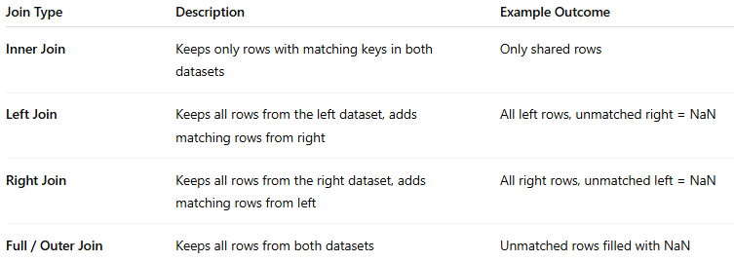
Join Type | Description | Example Outcome
Inner Join | Keeps only rows with matching keys in both datasets | Only shared rows
Left Join | Keeps all rows from the left dataset, adds matching rows from right | All left rows, unmatched right = NaN
Right Join | Keeps all rows from the right dataset, adds matching rows from left | All right rows, unmatched left = NaN
Full / Outer Join | Keeps all rows from both datasets | Unmatched rows filled with NaN

Example
# Source: AI Source: Provided by: [Data Path: Persons Table -> ID Column: 1, Name_En Column: Motasem Essam] -> From: [Chatgpt (GPT‑5 Mini)] on [12/10/2025]
Dataset A: Customers
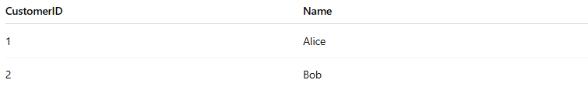
CustomerID | Name
1 | Alice
2 | Bob
Dataset B: Orders
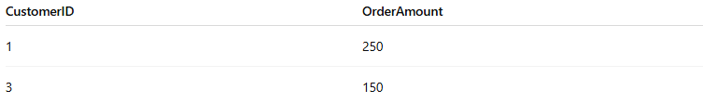
CustomerID | OrderAmount
1 | 250
3 | 150
Inner Join on CustomerID:
CustomerID | Name | OrderAmount
1 | Alice | 250
Left Join on CustomerID:
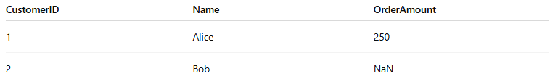
CustomerID | Name | OrderAmount
1 | Alice | 250
2 | Bob | NaN

Applications
# Source: AI Source: Provided by: [Data Path: Persons Table -> ID Column: 1, Name_En Column: Motasem Essam] -> From: [Chatgpt (GPT‑5 Mini)] on [12/10/2025]
- Combining customer and order data
- Integrating multiple datasets in analytics
- Preparing data for machine learning or reporting
- Linking experimental and demographic data

Advantages
# Source: AI Source: Provided by: [Data Path: Persons Table -> ID Column: 1, Name_En Column: Motasem Essam] -> From: [Chatgpt (GPT‑5 Mini)] on [12/10/2025]
- Enables comprehensive datasets by combining related information
- Flexible with different join types
- Widely supported in tools like pandas, SQL, and Excel

Disadvantages
# Source: AI Source: Provided by: [Data Path: Persons Table -> ID Column: 1, Name_En Column: Motasem Essam] -> From: [Chatgpt (GPT‑5 Mini)] on [12/10/2025]
- Requires clean and consistent keys
- Mismatched or duplicate keys can lead to unexpected results
- Large datasets may result in high memory usage

